Detailed Design – Practice Arena
Personalized Music Practice Recommendation System

1. Project Scope and Requirements

Project Scope
Practice Arena is a web-based personalized music-practice recommendation system designed for musicians (initially guitar players).
The system dynamically generates daily practice sessions based on user context such as emotional state, available time, goals, and historical performance data.
The project focuses on:
- Context-aware recommendations
- Adaptive difficulty
- Long-term progress tracking
- Intelligent content retrieval (videos, exercises)

2. Modular Architecture
The system is designed as a modular, layered architecture:

Main Modules
- Client (Frontend)
  - User input
  - Dashboard
  - Practice plan display
- REST API Layer
  - Communication between client and backend
  - Authentication and validation
- Core Logic Layer
  - Recommendation algorithm
  - Difficulty adaptation
  - Session scoring
- Data Layer
  - User profiles
  - Practice history
  - Metadata
- RAG Module
  - Vector search for learning content
  - External content integration

3. Programming Languages and Tools
Languages & Frameworks
Layer | Technology
Frontend | React (TypeScript)
Backend | Node.js + Express (the use of both front and back maybe will be in next.js)
Algorithm | JavaScript + Python (logic-focused)
Database | PostgreSQL
Vector DB | Chroma
Cloud | Vercel

Development Tools
- IDE: VS Code
- Version Control: Git + GitHub
- API Testing: Postman
- Debugging: Node Inspector
- Documentation: Markdown + OpenAPI

4. Coding Standards and Guidelines
General Rules
- Meaningful variable names (practiceScore, not x)
- One responsibility per function
- No business logic inside controllers
- Consistent folder structure
Version Control
- Feature-based branches
- Mandatory commit messages:
  - feat: add practice scoring
  - fix: handle empty session

5. Utilities and Libraries
Shared Utilities
- Database Utils
  - Connection pooling
  - Query helpers
- Scoring Utils
  - Normalize scores
  - Difficulty adjustment helpers
- Time Allocation Utils
  - Split session into blocks
  - Respect minimum task duration
- Vector Search Utils
  - Embedding generation
  - Similarity ranking

6. Sample Code and Reference Implementation
Skeleton Structure
/client
/components
/pages
/server
/controllers
/services
/algorithms
/rag
/utils
Reference Flow

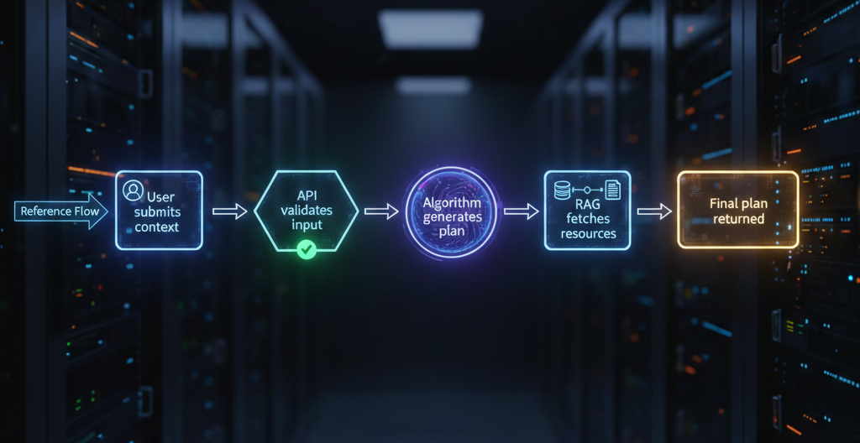

7. Documentation Templates
Required Documents
- Requirements Specification
- System Architecture Document
- Algorithm Description
- Test Plan
- User Guide
Each document follows a fixed template to ensure consistency.

8. Testing Framework
Tools
- Jest (unit tests)
- Supertest (API tests)
- Mocked RAG responses
Test Types
- Algorithm correctness
- Edge cases (0 minutes, missing history)
- Performance testing
9. Infrastructure and Deployment
Environment
- Development: Localhost
- Production: Vercel
- Database: Managed PostgreSQL
Deployment Tools
- Environment variables
- Automated build scripts

10. Monitoring and Troubleshooting
- Centralized logging - Winston module
- Error classification (logic vs system) - Custom error classes
- Session failure detection - Logic checks + logs

11. Timeline
- Week 1-2: Setup frameworks, finalize schemas, Deployment
- Week 3-4: Work on backend API endpoints, implementing the Algorithm
- Week 5-6: Implement React frontend components & The Rag Logic
- Week 7: Testing and debugging
- Week 8: Documentation

Algorithm Description – Practice Recommendation Engine

Description:
- Receive user context (time, emotion, goal)
- Load user history and skill level
- Determine target difficulty
- Allocate time blocks
- Select suitable exercises
- Retrieve relevant learning resources
- Rank and assemble final practice plan
- Return structured session

Pseudocode:

function generatePracticeSession(userContext, userHistory):

difficulty ← computeDifficulty(userHistory)
timeBlocks ← splitTime(userContext.availableTime)

for each block in timeBlocks:
task ← selectTask(block, difficulty, userContext.goal)
resource ← retrieveContent(task)
session.add(task, resource)

return session

Time Complexity
- Practice generation: O(n) -> (n = number of practice blocks)
- Vector search: O(log m) -> (m = number of indexed resources)

Space Complexity
- Session storage: O(n)
- History access: O(1) per user

Client-Side (Frontend) Components
1.1 Authentication Component
Responsibility
User login / signup
Why it exists
Separates security concerns from business logic
Inputs
Email, password
Outputs
- User session state

1.2 User Profile Component
Responsibility
- Create and edit static user data
- Instrument, experience level, goals
Why
- Defines initial constraints for recommendations (difficulty bounds)

1.3 Context Input Component
Responsibility
- Collect dynamic session data:
  - Mood
  - Available time
  - Practice focus
Why
- Context-aware systems depend on real-time user state

1.4 Practice Plan View Component
Responsibility
- Display generated practice session
- Show tasks, durations, resources
Why
- Presentation-only, no logic

1.5 History & Analytics Dashboard (will be divided to more components later)
Responsibility
- Display past sessions
- Progress graphs
- Improvement trends
Why
- Supports reflection and long-term engagement

2. API Layer (Backend Interface Components)
2.1 Authentication API
Responsibility
- Validate credentials
2.2 User Profile API
Responsibility
- CRUD operations on user profiles

2.3 Session API
Responsibility
- Receive context input
- Return generated practice plan

2.4 History API
Responsibility
- Store completed sessions
- Fetch analytics data

3. Core Logic Components
3.1 Recommendation Engine (Core Algorithm)
Responsibility
- Decide what the user should practice
Inputs
- User profile
- Context input
- Historical performance
Outputs
- Structured list of practice tasks
This is the heart of the system.

3.2 Difficulty Adaptation Component
Responsibility
- Adjust task difficulty over time
Logic
- Increase difficulty if success rate is high
- Decrease difficulty if frustration or failure detected

3.3 Time Allocation Component
Responsibility
- Split available time into meaningful blocks
- Ensure minimum task duration
Example:
- 20 minutes can be (depending on the user profile) → 3 small tasks × ~6–7 minutes

3.4 Scoring & Feedback Component
Responsibility
- Score completed sessions
- Normalize results
- Feed back into recommendation engine

4. Data Management Components
4.1 User Data Store
Stores
- Profile
- Preferences

4.2 Practice History Store
Stores
- Session logs
- Scores
- Metadata

4.3 Content Metadata Store
Stores
- Exercise tags
- Skill level
- Topic mapping

5. RAG (Retrieval-Augmented Generation) Components
5.1 Embedding Generator
Responsibility
- Convert text (exercise descriptions, queries) into vectors

5.2 Vector Database
Responsibility
- Store embeddings
- Perform similarity search

5.3 Content Retrieval Component
Responsibility
- Retrieve best matching learning resources
- Rank by relevance

5.4 Contextual Filter
Responsibility
- Filter content by:
  - Skill level
  - Time constraint
  - Emotional state

6. Utility & Cross-Cutting Components
6.1 Logging Component
Responsibility
- Record system behavior
- Debug algorithm decisions

6.2 Error Handling Component
Responsibility
- Graceful failures
- User-friendly messages

6.3 Configuration Manager
Responsibility
- Environment variables
- Feature toggles

7. Testing Components
7.1 Algorithm Test Module
- Tests recommendation correctness
7.2 API Test Module
- Endpoint validation

Use case Diagram:
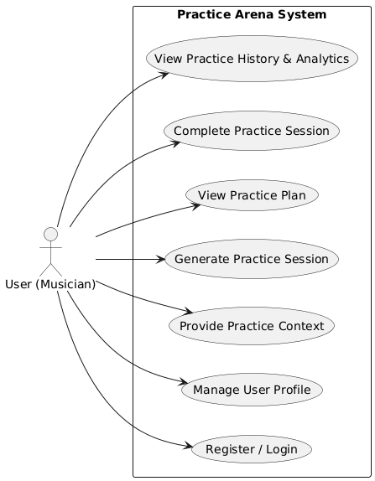
The use case diagram presents the functional requirements of Practice Arena from the user’s perspective. The primary actor is the musician, who can manage a profile, provide context, generate practice sessions, and track progress. The diagram intentionally abstracts internal logic and focuses on system functionality.

Sequence Diagram – Generate Practice Session Flow

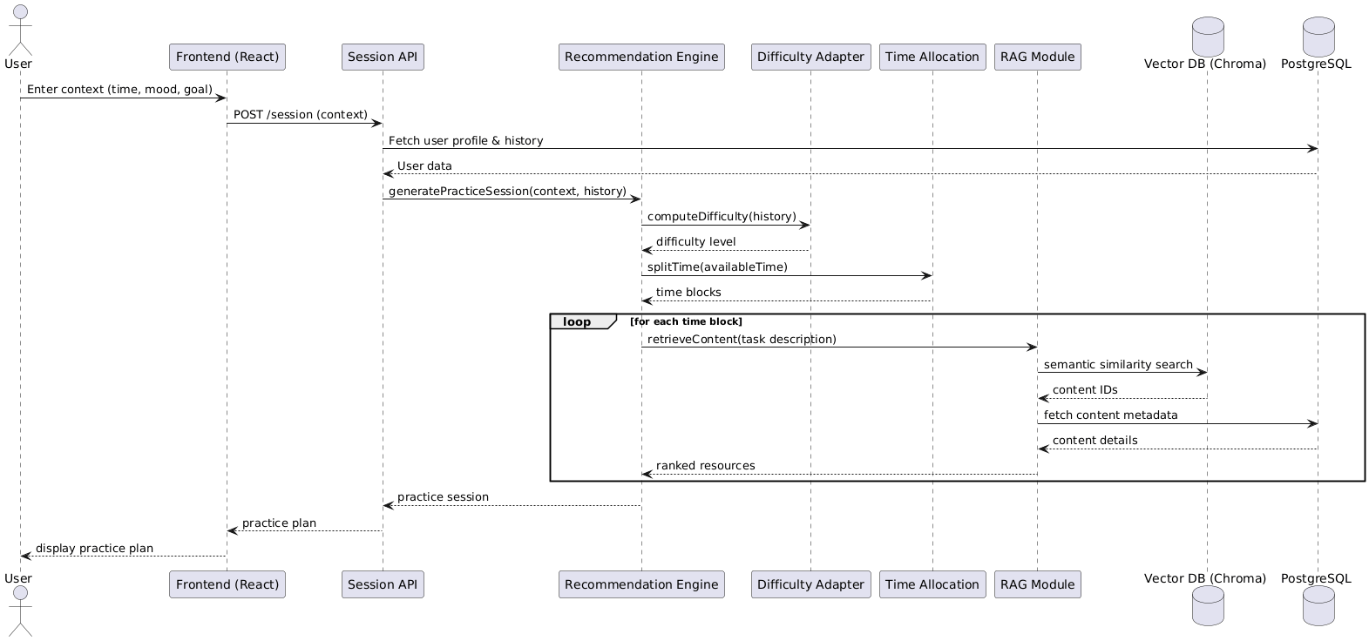

The sequence diagram illustrates the runtime interaction between frontend, backend, core logic, and data layers during practice session generation. It highlights the separation of concerns, the adaptive recommendation flow, and the integration of a RAG module using a vector database alongside PostgreSQL.

